**NMAP SCANNING**

[Nmap Scanning - OSCP Playbook (gitbook.io)](https://fareedfauzi.gitbook.io/oscp-playbook/port-scanning/nmap-scanning)

SWITCHES:

* -sV : services and version
* -sC : enable nmap script scan. It runs a set of default scripts to discover information about the target.
* -O : operating system
* -oA nmap/initial : specifies the output format and directory. Output will be .nmap , .xml and grepable(.gnmap)

INITIAL TCP SCAN

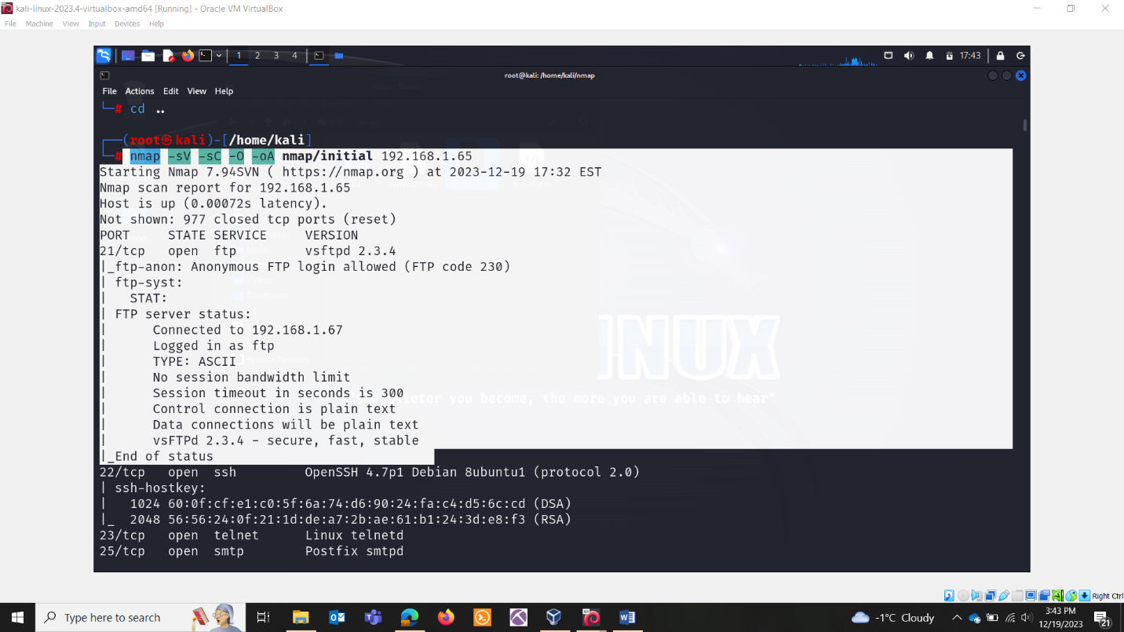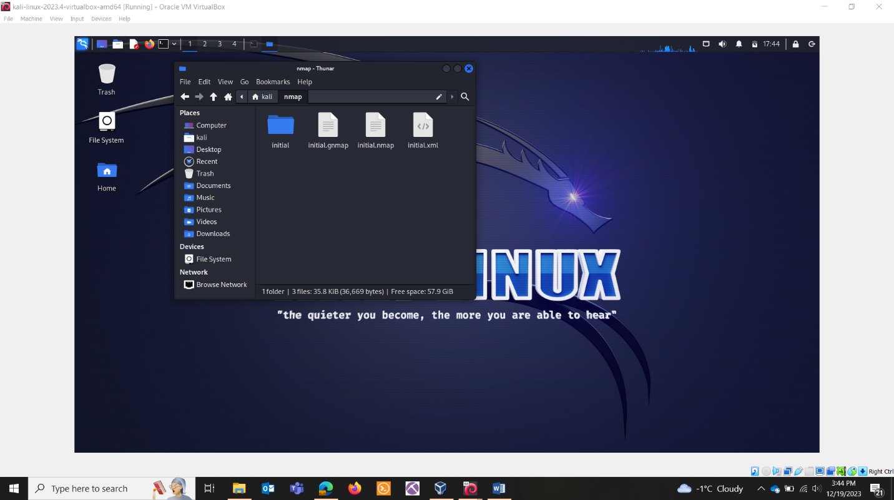

FULL TCP SCAN

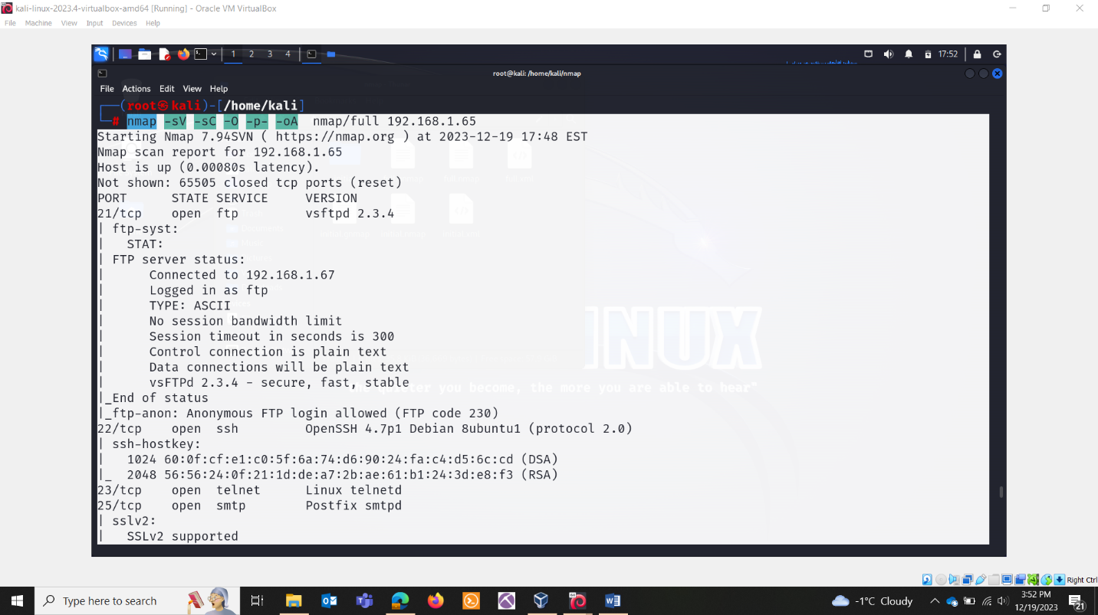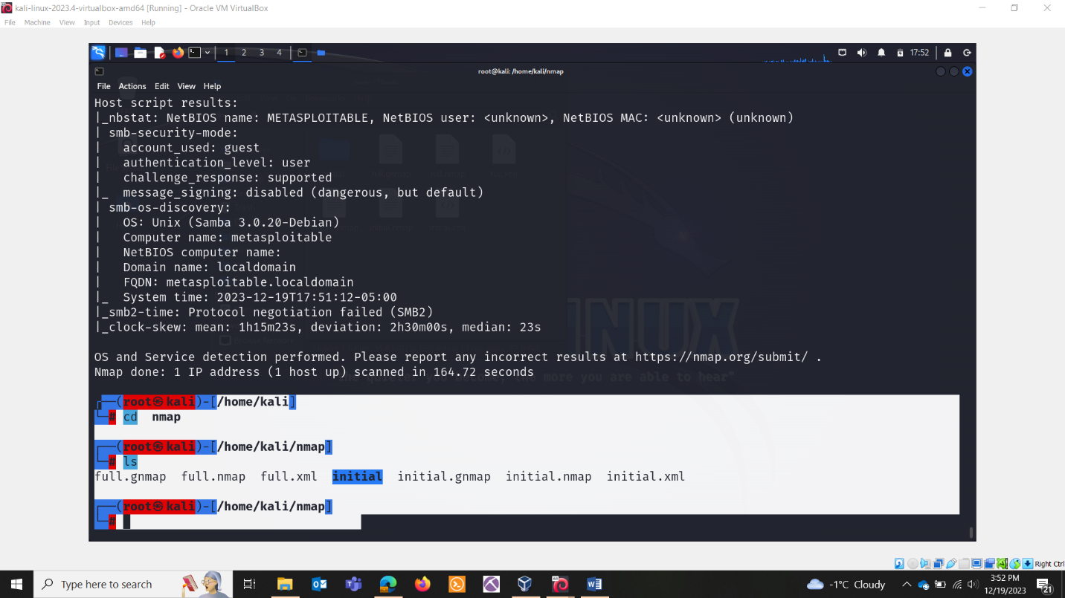

FULL UDP SCAN

nmap -sU -O -p- -oA nmap/udp ip.IP.IP.IP

NORMAL SCAN

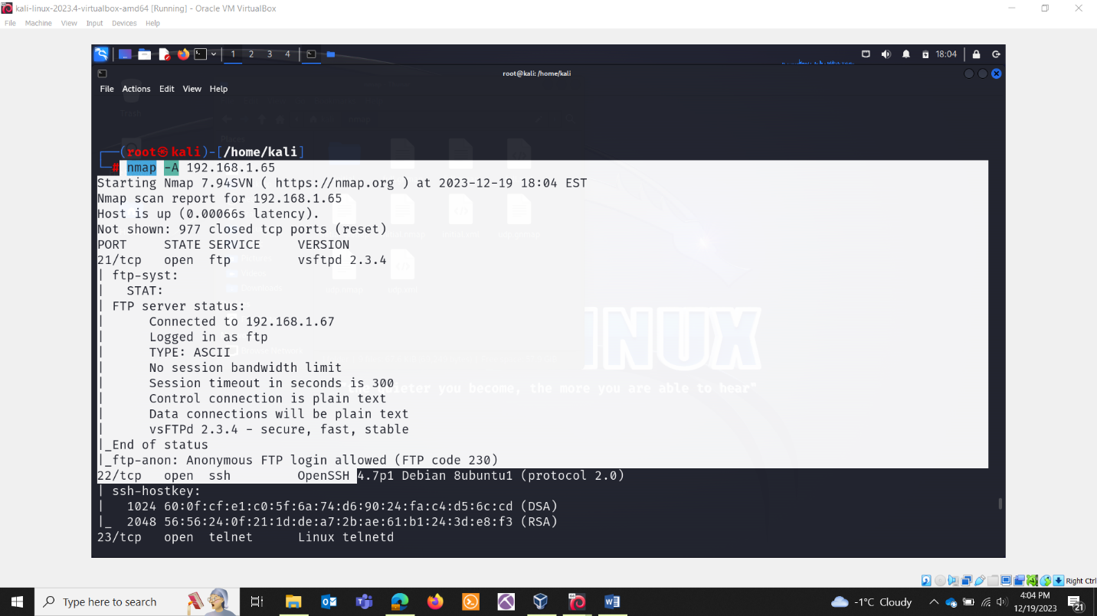

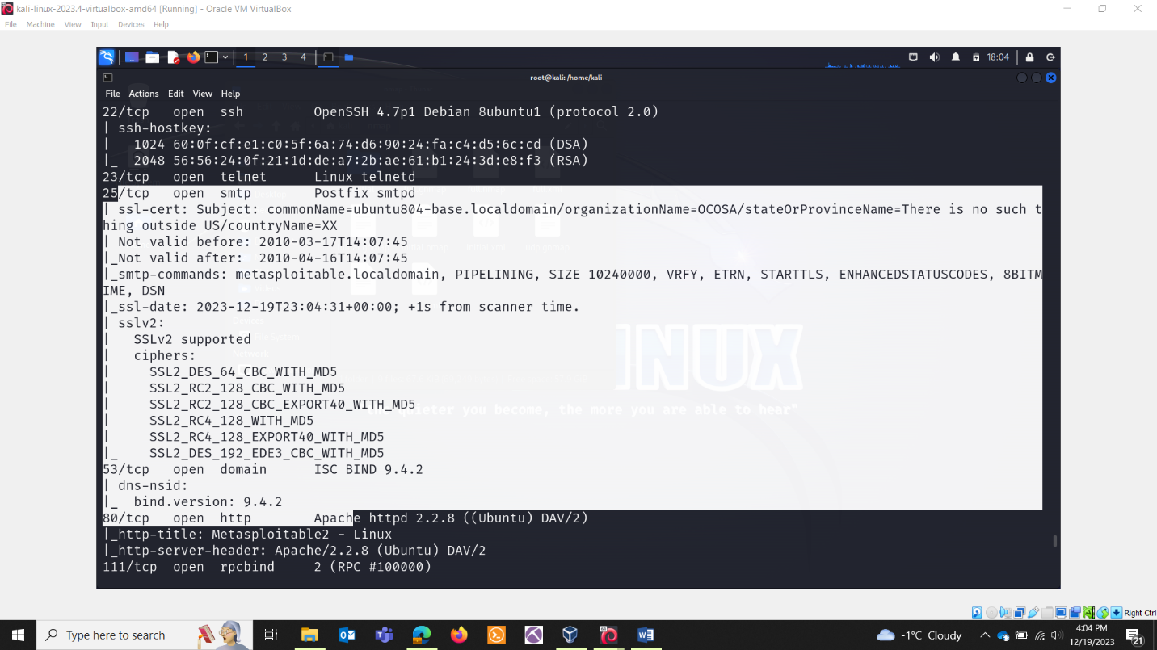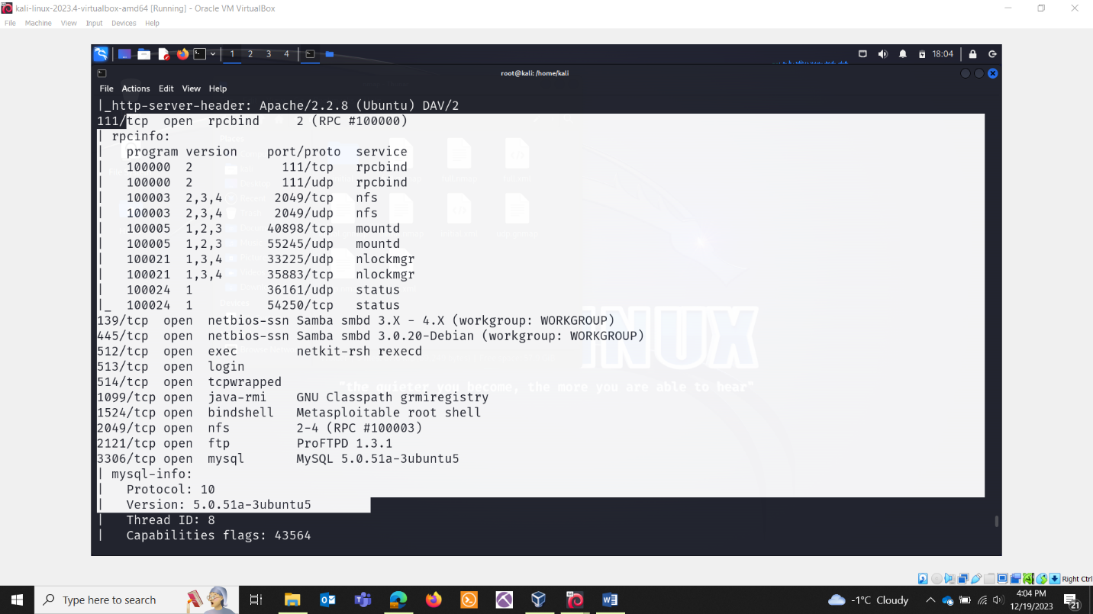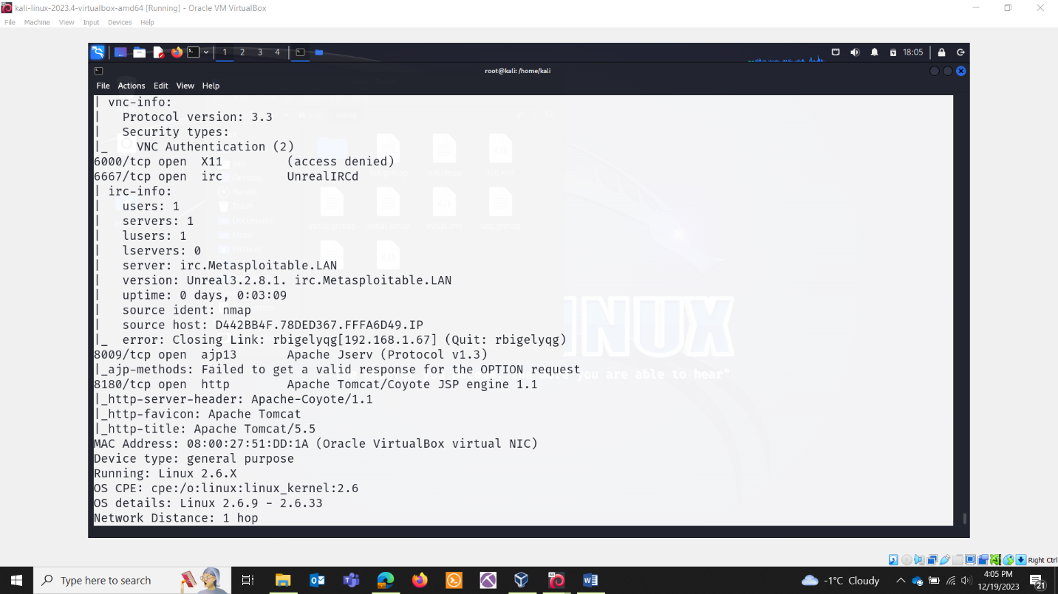

SCAN FOR ALIVE HOSTS

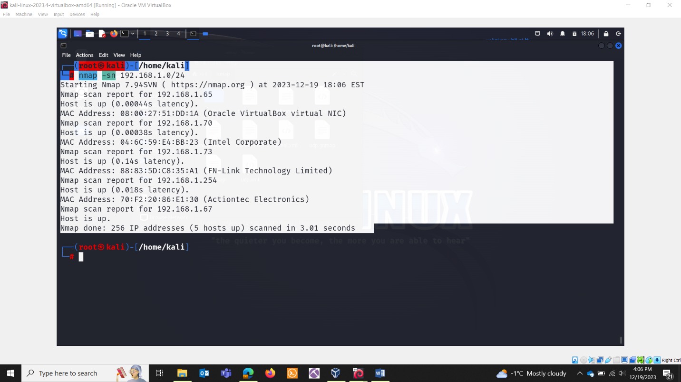

-vvv : very very verbose

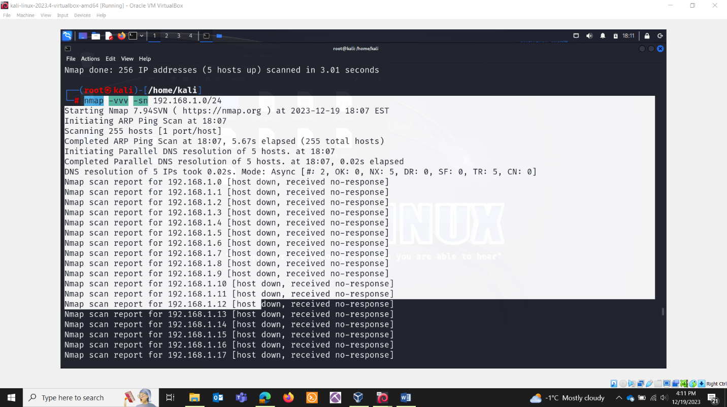

Particular range

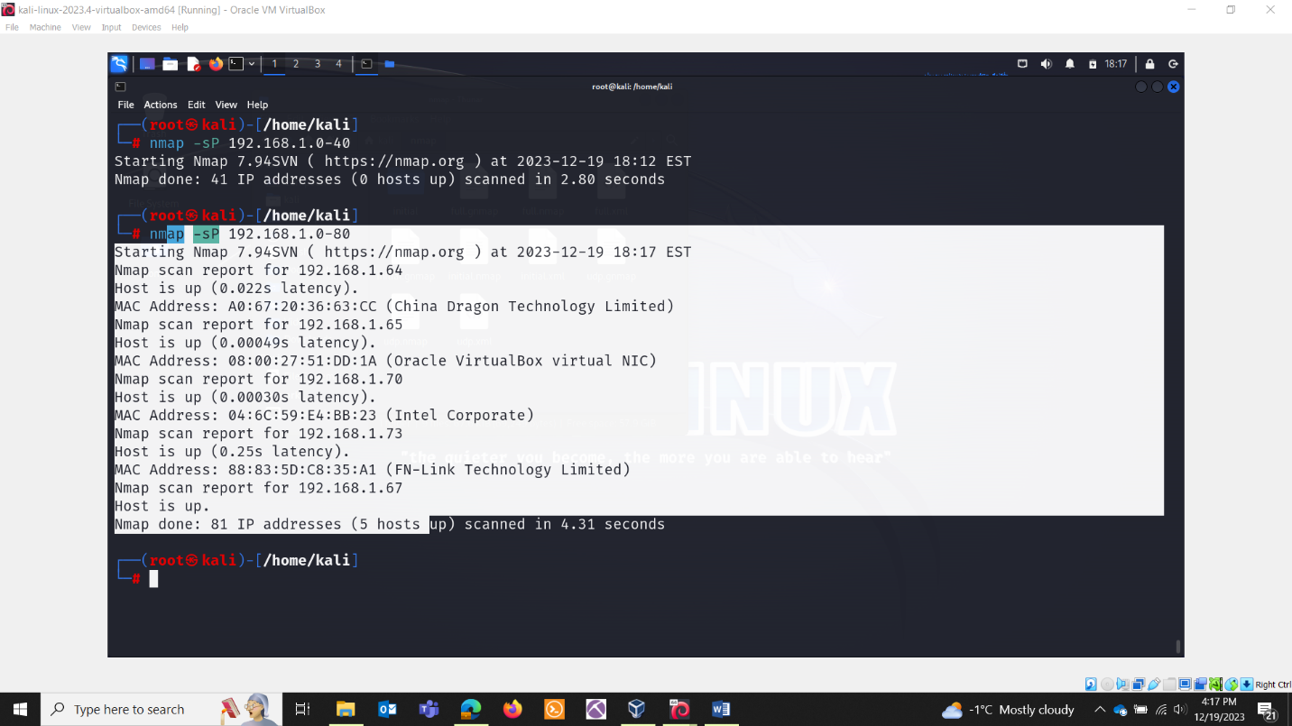

FASTER:

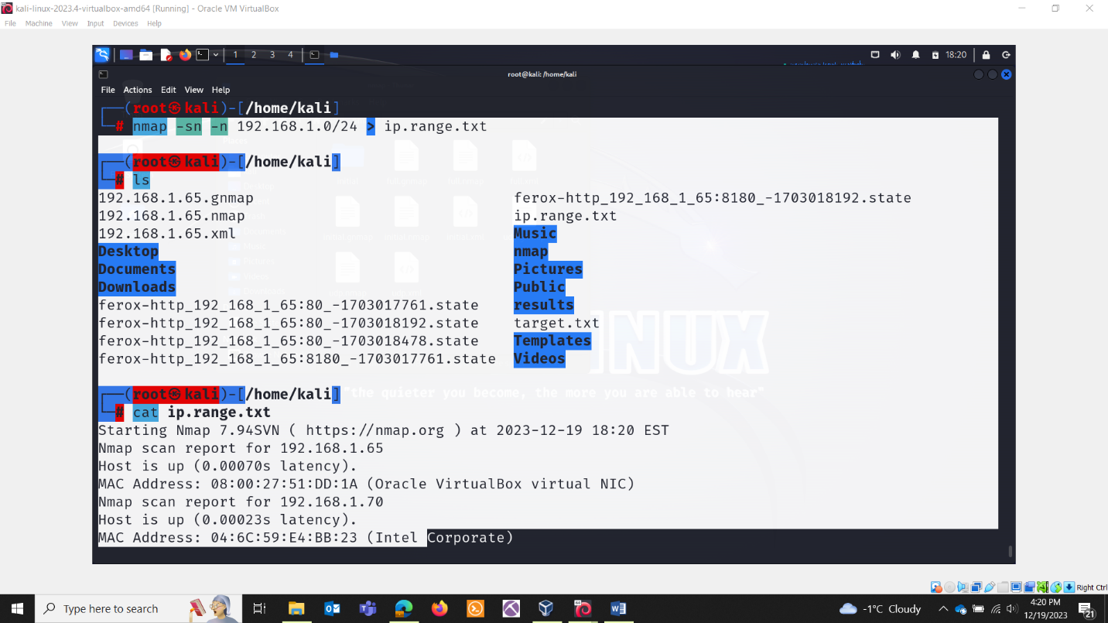

Only hosts which are up:

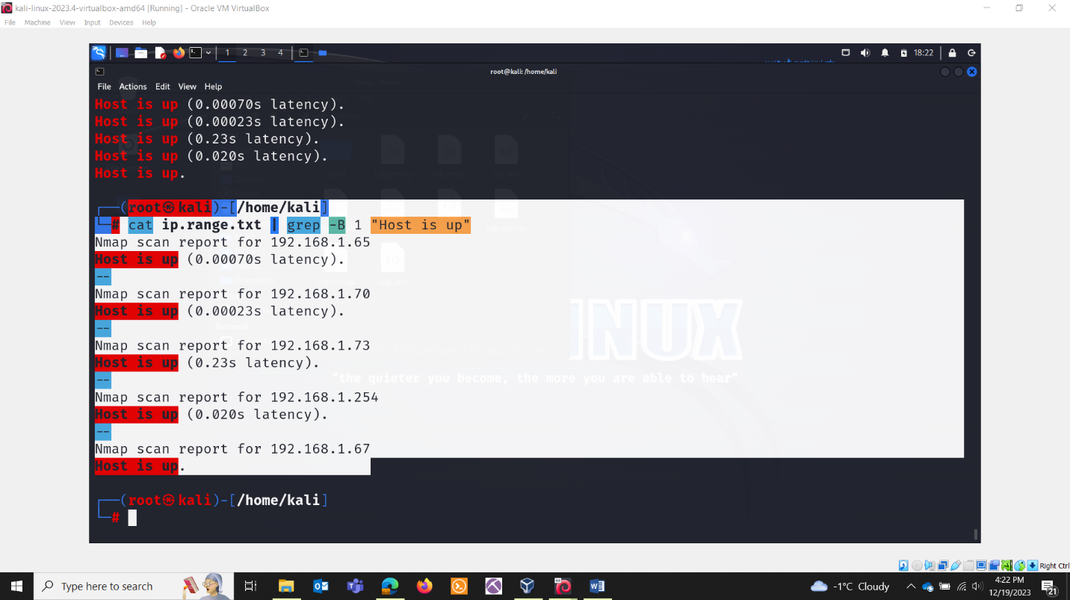

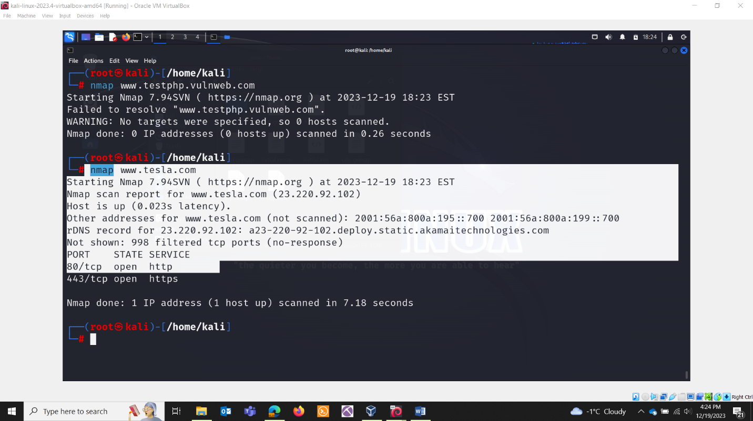

FAST SCAN:

Scan 100 common ports

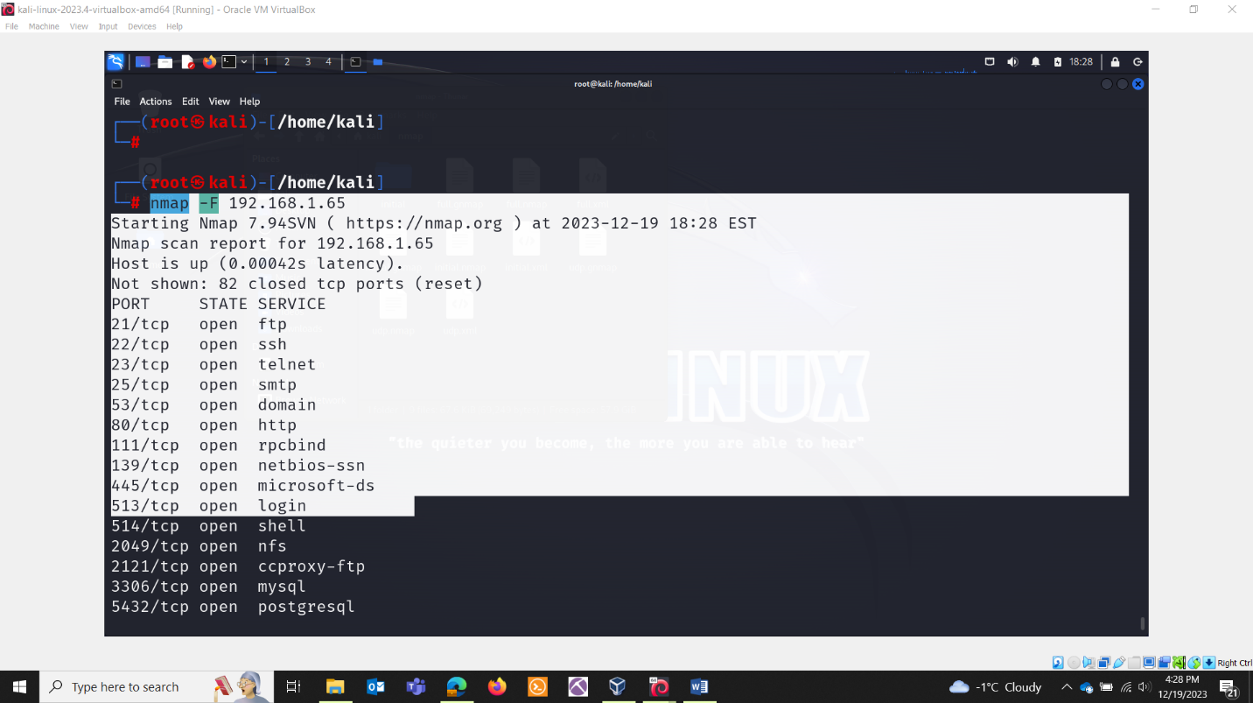

QUICK TCP SCAN:

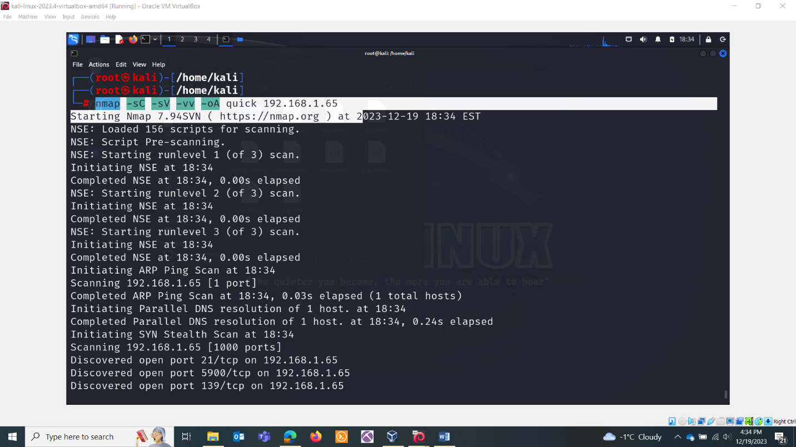

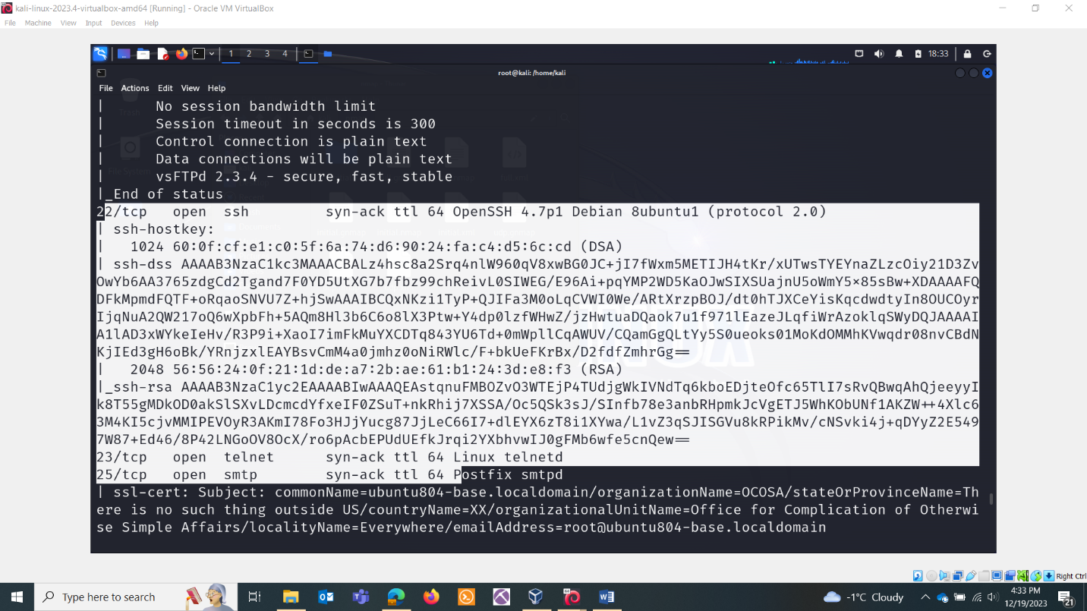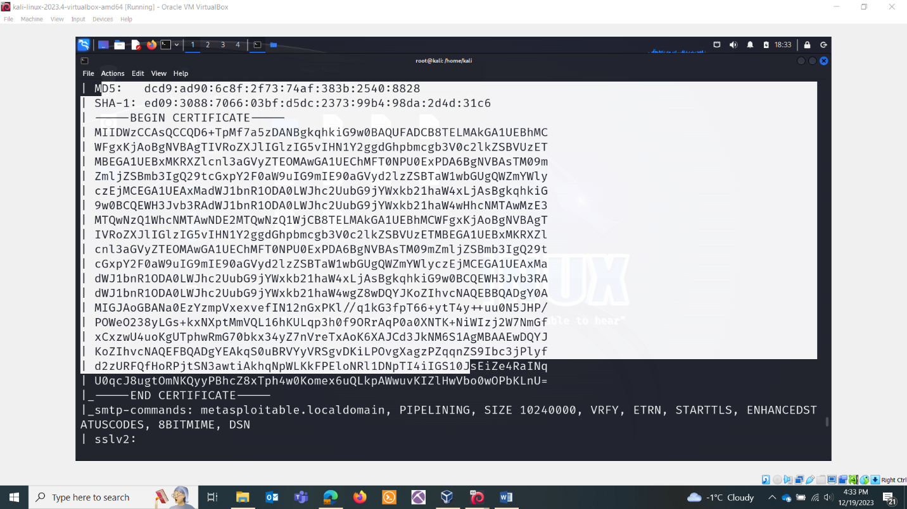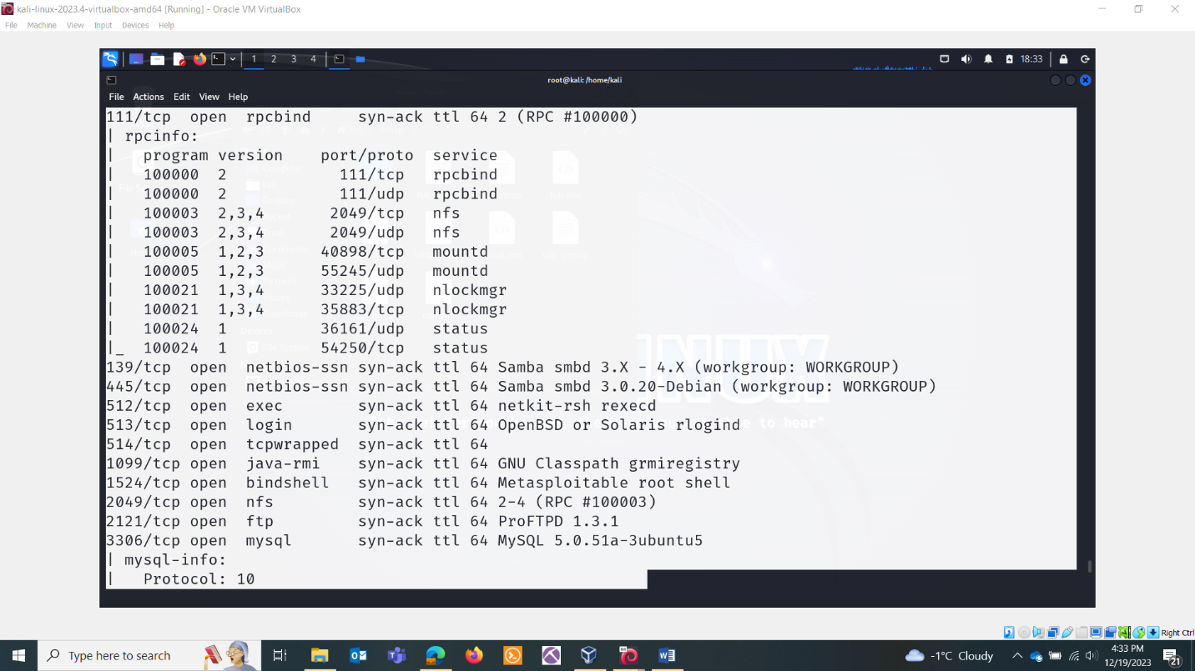

FAST UDP SCAN:

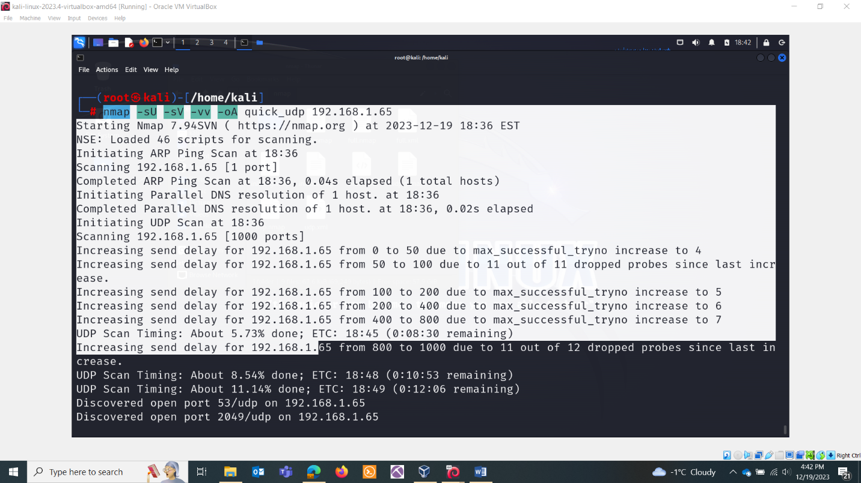

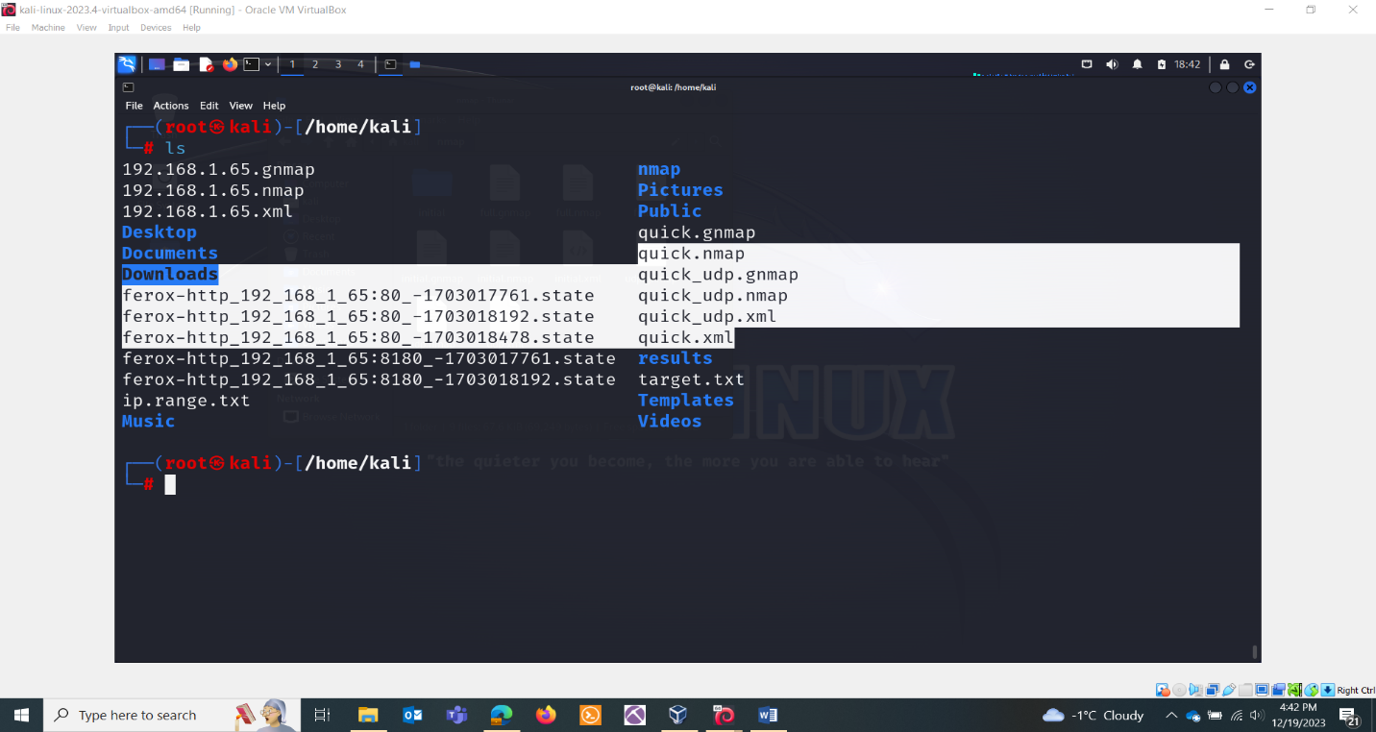

Unicornscan

**Onetwopunch.sh**

"OneTwoPunch" refers to a penetration testing tool that combines two well-known tools for network scanning: Nmap and Unicornscan. The tool automates the process of using these scanners in sequence to provide a more comprehensive view of the target network.

Here's a general overview of how OneTwoPunch typically works:

* Nmap: The tool starts by using Nmap for initial host discovery and service enumeration. Nmap is a powerful network scanning tool that can identify open ports, services, and operating systems on target systems.
* Unicornscan: Once Nmap completes its scan, OneTwoPunch leverages Unicornscan for more detailed service enumeration and additional information gathering. Unicornscan is another network scanning tool known for its speed and efficiency.

Grab the latest bash script

* git clone https://github.com/superkojiman/onetwopunch.git
* cd onetwopunch

Create a text file contains of our targets machine (like in method Scan for unused IP addresses and store in text file):

* 192.168.1.65

Then, run the script and tell it to read our txt file and perform TCP scan against each target.

./onetwopunch.sh -t t.txt -p tcp

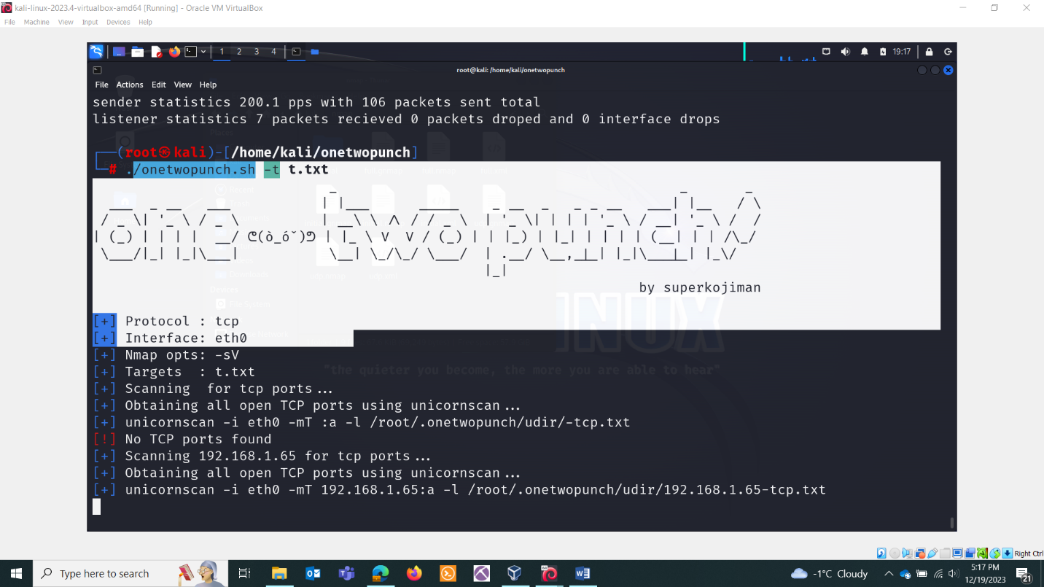

If you want to scan a particular port for all the machines:

